**Lab 5: Electrical Recording of Muscle Movements**

1. Introduction
2. Electromyography
3. Role of the Gastrocnemius
4. Gastrocnemius Activity While Walking
5. Electrical Activity and Force
6. Electrical Activity and Muscle Fatigue

VII. Study Questions

VIII. Guidelines for lab report

**Note: We will be using a Jupyter notebook to do the data analysis for this lab. You will receive more information about this during lab. Please be flexible, because you may do the data analysis slightly differently than what is written in the lab notebook.**

**I. INTRODUCTION**

In this lab you will use recording electrodes to "listen" to the electrical activity of a muscle during voluntary contractions.  The recording of electrical spikes representing action potentials in the muscle fibers is called an electromyogram (EMG).  You will use this technique to examine the change in electrical activity as force is increased and also to examine when a muscle is active during a complex movement.  
  
The two general questions that you will address in this investigation are:  
  
1. What is the role of the gastrocnemius muscle in walking?  
2. How does electrical activity in the forearm change as force increases?  
  
**II. ELECTROMYOGRAPHY**

An EMG can be obtained by attaching two electrodes to the skin directly over a muscle and recording the potential difference between them as the muscle contracts.  A third electrode is used as a ground and may be attached anywhere nearby, preferably not directly over a muscle.  Action potentials traveling along a motor neuron create an electrical signal too weak to be detected by these electrodes.  However, when the action potential reaches the motor endplates of the hundreds of muscle fibers in the motor unit, action potentials occur nearly simultaneously in all the muscle fibers.  The combination of all of these muscle action potentials, called a motor unit action potential (MUAP) creates a large enough electrical disturbance to be detected with surface electrodes.  A MUAP from two surface electrodes normally appears as a single biphasic spike.  The amplitude and shape of the spike depends on the size of the motor unit, the position of the electrodes relative to the motor endplates, and the distance between the electrodes and the fibers.  MUAPs from two motor units passing under the electrodes at the same time add to each other.  When potentials from several motor units combine, the EMG pattern becomes very complex and it is not possible to tease apart the activities of individual motor units.

**III. Role of the Gastrocnemius**

EMGs can be used to determine when various muscles are activated as a subject runs, types, or hits a tennis ball.  By correlating EMGs with kinematic measurements, one can analyze the timing and coordination of muscle use in that activity.  For the first portion of the lab we will be analyzing the gastrocnemius, a large muscle located on the back of the lower leg that is involved in standing, walking, running, and jumping.  The medial head of the gastrocnemius originates from the medial femoral condyle and inserts into the calcaneous bone through the Achilles' tendon.  Thus it crosses two joints, the knee and the ankle.  You will test its effect on each joint by sitting on a lab table and moving one joint at a time while recording the EMG.  To see how the gastrocnemius functions in walking, you will record an EMG while walking slowly around your station, or while walking on a treadmill if you want to try higher speeds without interference from the tether.    
  
Questions to Answer:  
1. What role, if any, does the gastrocnemius play in movement of each joint?  
2. When does the gastrocnemius contract during walking?  
3. When it contracts during walking, is it shortening (concentric contraction), lengthening (eccentric contraction), or both?

**Fig. 1** Gastrocnemius electrode placement on right leg

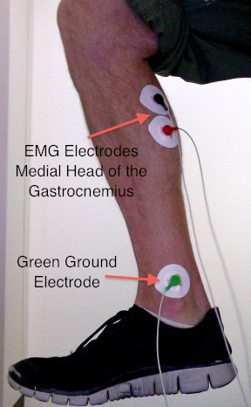

Methods

1. To assure a good electrical contact, clean the skin vigorously with an alcohol wipe before applying the electrodes, and allow the skin to dry completely.  If there is a lot of hair, it may help to shave a small patch of skin.  Peel the backing from a disposable electrode and apply the electrode to the skin, pressing the adhesive ring to attach it securely.  The electrode leads plug into a ten-foot long extension cable, which in turn plugs into the iWorx.

You need two shielded electrodes (black is negative, red is positive) and one unshielded ground electrode (green) to record an EMG.  To record from the medial head of the gastrocnemius, the positive and negative recording electrodes should be placed on the back of the calf along the axis of the leg, with the upper electrode about a handbreadth below the popliteal crease (back of the knee).  The electrodes can be spaced 1-3 cm apart.  The ground electrode should be placed on the inside of the ankle just above the medial malleolus. See Fig. 1 for electrode placements.

2. Open the LabScribe software and begin recording on the computer with the setting file “Gastrocnemius Activity”.  Your subject should try alternating strong contractions of the gastrocnemius with complete relaxations (see Fig. 2).  If the EMG signal is very small, press the autoscale button to zoom in on the relevant outputs.  The signal you see between sets of spikes represents electrical noise, which may come from a variety of electrical fields in the room.  A common noise pattern is a 60 Hz sine wave from the alternating (AC) electrical system in our building.  Sometimes you can reduce noise by moving the signal cables so that they do not run close to a power cable or electrical appliances. 

3. Start recording again and jiggle the electrode wires.  What do you see?  Is this signal physiological (does it originate from the gastrocnemius) or is it from an outside source? Remember to try to control for this noise as you make all your EMG measurements.

Fig. 2 Example tracing of the gastrocnemius electrical activity during a series of joint movements

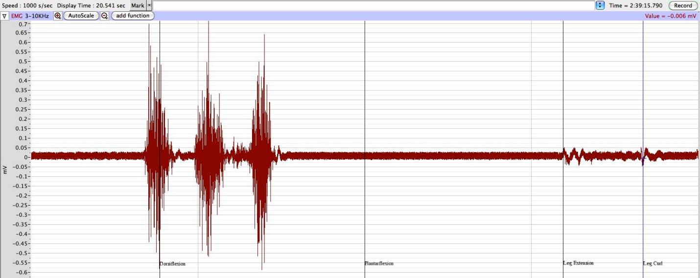

**Plantarflexion**

**Dorsiflexion**

**Leg Extension**

**Leg Curl**

4. With the three electrodes connected to your leg, sit on the table and point your foot down like you are pushing on a gas pedal (plantarflexion) and record the EMG activity (Fig. 3).  Take care to minimize movement of the wires during the movement.  Next point your toes up (dorsiflexion) and record the electrical activity (see Table 1).  During which movement at the ankle joint is the gastrocnemius most active?

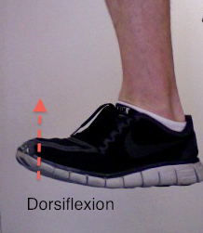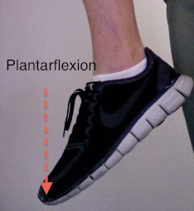

**Fig. 3** Pictures of dorsiflexion and plantarflexion.

5. Next extend your leg out in a slow kicking motion while making sure to keep your ankle joint in a locked position.  It is very important that you pay attention to movement of the wires in this condition.  You may need to hold the electrode box or tape the wires to the leg to minimize movement artifacts. Now contract your hamstring so that your heel approaches the bottom of the table.  Under what condition was the gastrocnemius most active?

**Table 1**

|  |  |
| --- | --- |
| **Joint Motion** | **EMG Amplitude (Large /Medium/ Small / No Activity)** |
| Plantarflexion |  |
| Dorsiflexion |  |
| Leg Extension |  |
| Leg Curl |  |

**IV. Gastrocnemius Activity While Walking**

The term "contraction" generally implies shortening, but in muscle physiology contraction just means that a muscle is producing force.  Actively contracting muscles can shorten, remain the same length or be stretched by other forces.  The active muscle always exerts a force in the direction of making the muscle shorter, but whether the muscle actually shortens depends on the external load opposing the muscle's tension.  If the muscle's tension exactly balances the load without moving, the contraction is termed **isometric** ("same measure").   If the muscle shortens against the load, the contraction is termed **concentric**.  If the load is greater than the tension in the muscle, then the muscle lengthens as it contracts, an **eccentric** contraction (Fig. 4).  In this case it is the load that is causing the lengthening, with the muscle acting to slow it.  Eccentric contractions routinely occur during everyday movements, often acting as a brake for limb movements.    
  
We typically describe the function of a muscle by its action on the body when it shortens, e.g. the biceps flexes the elbow; the triceps extends the elbow.  Now picture yourself setting your brand-new $1,500 laptop down on a table.  This motion involves extending your elbow.  Do you relax your biceps and contract your triceps?  If you do, your precious load is converted into a heap of plastic and silicon shards!  Rather, the computer acts as a load to extend the elbow and you contract your biceps to resist and slow this extension to achieve a soft landing.  Thus the biceps can act either to flex the elbow or to resist extension of the elbow.

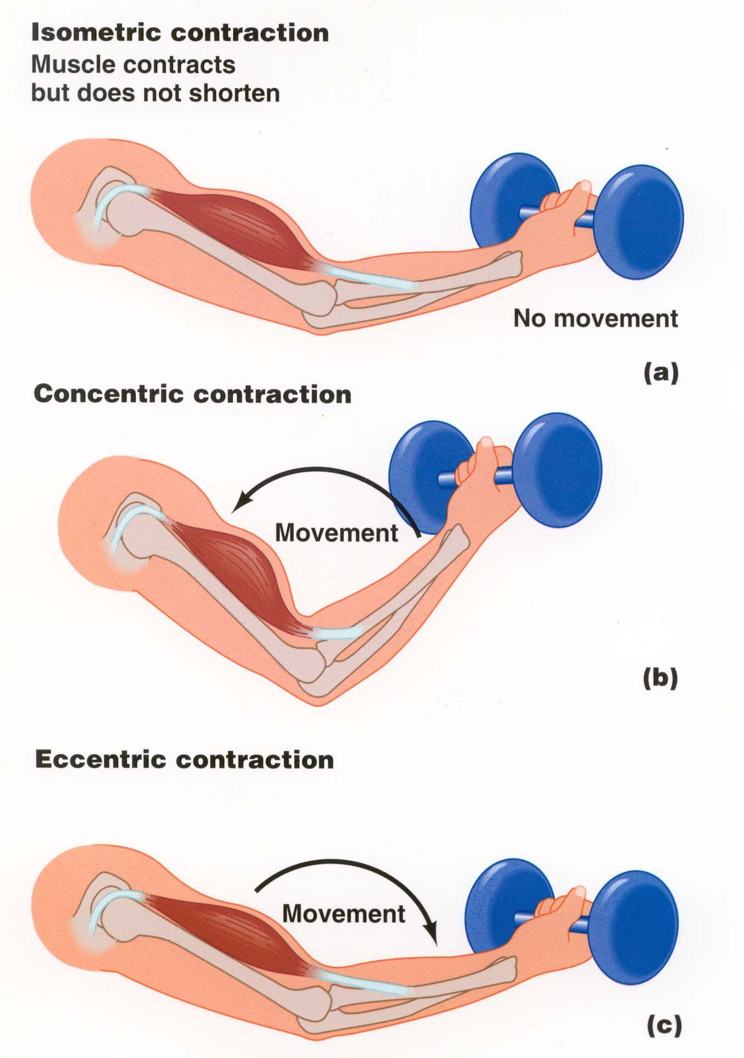

**Fig. 4** Types of muscle contractions

In this second experiment you will determine when during the gait cycle the gastrocnemius is active and what type of contraction it is.

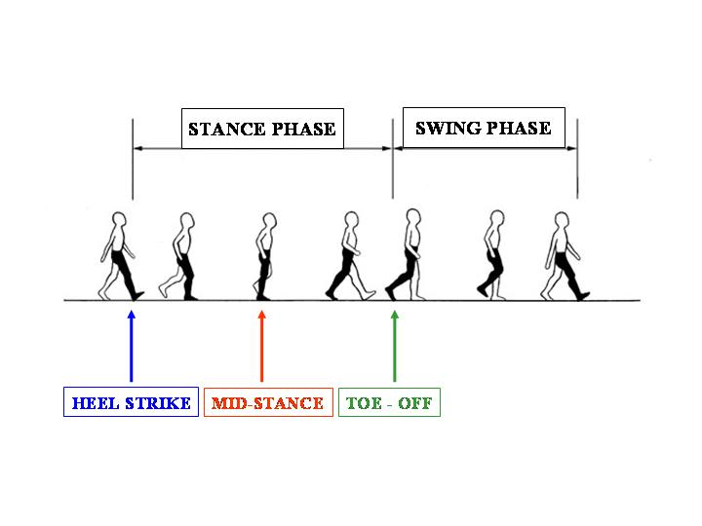Methods  
1. Walk around your desk while another student uses the hand switch (event marker) to mark different parts of the gait cycle.  With the length of the wires you should be able to perform two strides.  To reduce noise from movement of the wires while you are walking, wrap an ace bandage around your leg and the electrode wires. You should perform several trials where you push the event marker for each of the following times (see Figure 5):

**Fig. 5** Gait Cycle during walking

1. Heel strike  
2. Mid-stance  
3. Toe-off  
4. Swing phase

You should have the subject walk and then push the event marker during the heal strike 3 times. Then do the same for mid-stance, etc. Record if the muscle was active or inactive in **Table 2**.

Remember to consider how much of the signal is from the muscle and how much is noise from movement of the wires.  It is also important to consider how your subject is walking.  Is your subject altering their gait because they are hooked up to recording equipment?  Are they walking more on their toes or more on their heels?  Are they walking unnaturally slowly because they are tethered to iWorx and someone is trying to record different motions?    
  
2. Since you have characterized when the gastrocnemius is active during walking, now try to determine whether the muscle is lengthening or shortening when it is active. You cannot determine whether the muscle is contracting eccentrically or concentrically from the EMG signal, only from watching your subject walk and thinking through what role the muscle is playing.  In **Table 2**, for the portions of the gait cycle where the muscle is active fill in whether the muscle is contracting eccentrically or concentrically. If the muscle is not active then leave the eccentric concentric space blank. Hint - if your subject is standing on their toes and they slowly lower themselves until their heel hits the ground, this is an eccentric contraction.  Do you think it matters if the subject walks on their heels or toes?

**Table 2**

|  |  |  |  |  |
| --- | --- | --- | --- | --- |
|  | **Ground Contact** | | | **No Ground Contact** |
|  | **Heel Strike** | **Mid-Stance** | **Toe-Off** | **Swing Phase** |
| **Active or Inactive** | Inactive |  |  |  |
| **Eccentric or Concentric** | N/A |  |  |  |

**V. ELECTRICAL ACTIVITY AND FORCE**

In addition to quantifying when a muscle is active, EMGs can also be used to quantify the level of muscle activation.  For the second portion of the lab you will determine the relationship between muscle force and EMG during forearm contractions.

Questions to Answer:  
1. What is the relationship between muscle force and EMG?  
2. Does this relationship change in a fatigued muscle?  
  
Methods

1. To measure the strength of your forearm contractions you will be using a bulb shaped dynamometer (dynamis = force, metron = measure).   Choose the setting file “Muscle Force and Electrical Activity”.

2. To use the dynamometer you will first need to determine a conversion factor for its output (a voltage) to force, and also determine if the output is linear over your measurement scale.  To do this, collect five heavy textbooks.  Then lay the dynamometer down on the bench top and click record as you stack the five textbooks one at a time on the bulb of the hand dynamometer. The books are not stable on the dynamometer so you will have to use both hands to help keep them stable.  Use a single cursor to measure the voltage at the peak for each set of textbooks. Record the voltage output for each textbook against its mass in the Jupyter notebook for Lab 5.

Was the output linear, such that for each increase in voltage there was a similar increase in force, or did the graph begin to plateau at higher forces?

Force (N) = mass of textbook in kg * 9.8 m/s2 (gravity)

1 Newton = 1 kg * m/s2

1 kg = 2.2lbs

Gravity = 9.8 m/s2

3. Next find the conversion factor for converting voltage into force in newtons. The Jupyter notebook will lead you through the process of linear regression and you will get an equation, which will allow you to convert Volts (from the dynamometer) to Newtons (force).

4. To record from the forearm muscles you will first need to use an alcohol swab to scrub the three regions on the inside of the subject's dominant forearm where the electrodes will be placed (see Fig. 6).  Near the wrist add the green electrode, in the middle of the forearm add the black electrode, and about two inches distal to the elbow add the red electrode.

Be sure to remove all jewelry from your wrists.  Once the electrodes are attached, contract your forearm muscles repeatedly by making a fist to confirm that you are getting an adequate signal.  Autoscale the EMG signal if necessary.

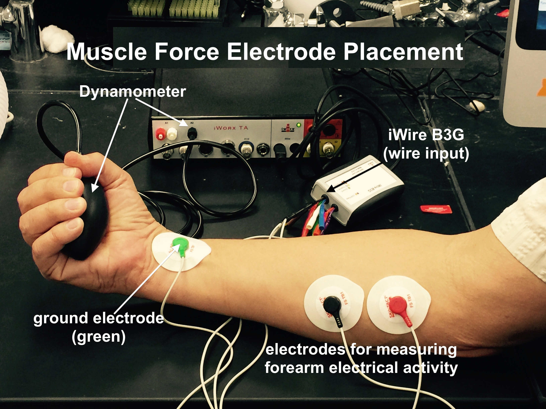

**Fig. 6** Set-up for recording electrical activity of forearm muscles

5. To begin collecting data, rest your arm on the table (to minimize movement of the electrodes while you contract your forearm).  Now squeeze the hand dynamometer five times: each contraction should be at least three seconds long followed by three seconds of relaxation.  Try to reach a steady state of force generation (i.e. the recording should be flat). Each successive contraction should be progressively stronger than the first contraction so that the last contraction is near maximal.   Use visual feedback from Labscribe to both adjust the strength of contractions and maintain the strength (dynamometer signal) throughout the three seconds. Repeat this sequence for a total of three trials (15 total contractions).  Try to match the same series of forces used for the previous trials.

Data Analysis

The EMG signal is the sum of the electrical activity from the active muscle fibers.  The signal can be changed by altering the number of muscle fibers that are active (recruitment), or by varying the frequency with which they are active (rate coding).  Ultimately, to increase force the body uses a combination of these two mechanisms.  Yet, this makes the electrical signal complex, as electrical signals add or cancel out each other as their activation properties change.  One way to quantify this signal is to determine the total electrical activity by taking the absolute integral of the EMG signal.  To determine the absolute integral of the EMG signal, the biphasic electrical activity is first rectified so that all the signals are positive.  Next the rectified signal is integrated over a fixed period of time.  In simple terms we are making the signal positive and then taking the area under the curve.  A larger integrated EMG indicates more muscle activity. Typical responses are shown in Figure 7.

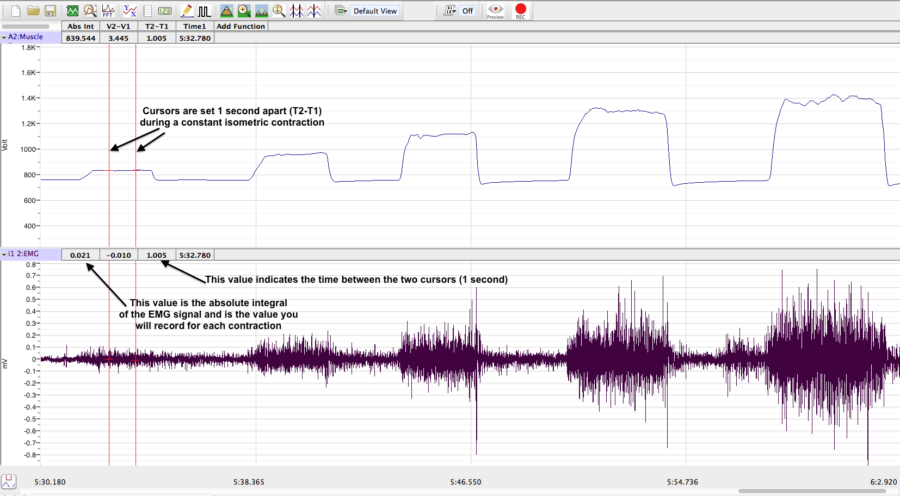**Fig. 7** Sample trace of force (top) and EMG activity (bottom) during a series of progressively larger forearm contractions

1. For your data go to the "analysis page." You can find the analysis page by either clicking on the box at the top that contains the magnifying glass (to the right of the green sine wave), or by going to the View pull down menu and selecting "analysis."

2. Once on the analysis page you should see "T2-T1," "V2-V1”, and "Abs Int" at the top of EMG and force panels.  Adjust the double cursors to record the middle second of each three-second contraction.  Use the T2-T1 value to make sure the cursors are set exactly 1.000 seconds apart, and record the "Abs Int" value for the EMG signal.  Record these values in the Jupyter notebook. For fine control of the cursors the arrow buttons on the keyboard can be used.  What happens if the times are not kept constant between measurements?

3. Use a single cursor to measure the peak of the voltage for each contraction of the dynamometer in the top panel.  Note that you can only use a single cursor in the data acquisition mode (in the main window). Next you will need to convert this voltage to Newtons using the equation you obtained from measuring your textbooks. Enter the voltage output for each contraction of the dynamometer into the table in the notebook. You will be guided through how to convert the voltage into force values using the equation from the calibration.

4. Repeat step 3 for the 2 other trials and enter values into appropriate tables in the notebook.

5. You will then graph the relationship between EMG and force. Include this graph in your lab report.

**VI. Fatigue EMG**  
The term fatigue refers to a variety of poorly understood phenomena, from a state of sleep deprivation to a symptom of metabolic abnormalities.  For this lab we will restrict ourselves to muscle fatigue defined as a reduced ability of the muscles to contract when stimulated.  When a group of muscle fibers is no longer able to produce the same amount of force the central nervous system needs to modify its output to maintain force. You will now attempt to see what happens to the EMG signal during fatigue.

Methods  
1.  First perform a brief maximal contraction (~3 seconds) while resting your arm on the table, and then calculate 50% of the maximal value.

2. Then perform a contraction at 50% of your maximum force and see how long you can maintain that force, likely between two and four minutes.   Use the background horizontal lines on Labscribe to maintain the force output or use the value in the upper right hand corner of the panel.  Hold the force at 50% of maximum as long as you can. When you can no longer maintain that force, immediately move on to the next step.

3. Immediately after you finish the 50% contraction perform five isometric contractions for 2 seconds each, exactly as you did when measuring force at increasing intensities in Section V. Remember that each contraction should last at least three seconds and be followed by three seconds of relaxation.

Data Analysis

Analyze the data like you did before to find the Abs Int value of the EMG signal. Enter the data in the Jupyter notebook and graph it as before. Your graph should contain the line from part V (without fatigue) and the line after fatigue. You will need to include these graphs in your lab report, so make sure everyone gets a copy of the graphs.

**VII. STUDY QUESTIONS**

1) When jumping up and down do you think the gastrocnemius would be more active when you leave the ground or when you land on the ground? (Feel free to try this measurement, but movement/noise from the wires while jumping can make it difficult)

2) Is the graph of Force versus EMG linear, or does the graph reach a plateau at higher forces?

3) Do you think the EMG readings will be the same among different subjects? What factors may cause different responses in different subjects? Do you think the relationship between EMG activity and force changes under different conditions?

4) From the five contractions you performed after the fatigue trial did the relationship between force and EMG change? Why would it change?

5) Can you think of other treatments that may change the slope of the EMG/Force graph?

6) Can you think of a cellular mechanism that could explain muscle fatigue? Note: it is currently thought that neither lactate build up nor decreases in intracellular ATP are the cause of muscle fatigue.

**VIII. LAB REPORT GUIDELINES**

**Introduction (20) [about 1 page long]**

* What is the main purpose behind the experiments in Lab 5? What processes are we trying to learn more about? (5)
* Background information (10)
  + Define motor unit and twitch.
  + How are motor units recruited (spatial vs temporal summation)?
  + Describe the different types of muscle movements (isometric vs concentric vs eccentric).
  + Go into detail of how a muscle generates force, especially with regards to the forearm exercise, including the relationship of electrical activity in the muscle and muscle force.
* State two separate hypotheses, one for muscle movement (gastrocnemius walking activity) and one for muscle force in the forearm (with and without fatigue). Give a brief biological explanation for your hypotheses. (5)

**Methods (15) [less than 1 page long]**

* List the set-up for all parts of the lab, include electrode placement. (5)
* Explain the procedures done to minimize background noise from your data. (2)
* Include how you calibrated the hand dynamometer and then did the force conversion for the forearm experiments (include the equation). (5)
* Explain how you analyzed the data in the forearm experiments. (3)

**Results (25)**

* Include all the tables in the lab manual (including for gastrocnemius experiments), as well as the graphs in the Excel spreadsheet (but not the calibration data). You do not need to include all the tables in the spreadsheet as long as all the data is represented in the graphs. (10)
* Remember to give all the tables and figures a title and legend. The legend must include a short description of how to read the data. (5)
* Write a brief description of all the data in the tables and graphs. Discuss the trends that you see, but do not try to interpret the data at this point. (10)

**Discussion (30) [1-3 pages]**

* Did the experiments support your hypotheses? Explain further referring to the data to support your statements. (10)
* Explain the physiology behind your results (10)
  + Address the role of the gastrocnemius during walking
  + Why does EMG activity change with increasing force? Explain using muscle physiology.
  + Explain the changes you saw with fatigue. What happens in muscles during fatigue? (Study question #5)
  + Include one real world application of EMG, such as for medical conditions.
* Even if the data fits your hypothesis perfectly, explain at least two possible errors that could have occurred (mechanical and manmade). If it doesn't fit your hypothesis, explain the possible errors that account for this discrepancy. How can you improve this experiment in the future? (5)
* Include a new experiment. Don't just have the exact same setup, and add no real changes to the lab. Consider something new that can add to the lab or measure a variable not considered. Include a hypothesis for your new experiment. (5)